Capri Terrace
Neighborhood Watch Meeting

Where: Glenn & Daphne Mathew @ 550 NE 167th Place
When: Sunday July, 13 at 6:00 pm
What to Bring? A side dish or dessert
Got questions? Call Glenn at 503.257.3111

Join us to discuss issues we feel are important to our safety.
This meeting will incorporate a short class on a skill we all need.
Come and enjoy food, friends, and some fun too!

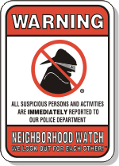

To report a crime in-progress, a fire, or a medical emergency, call: 9-1-1

To report non-emergency situations or crimes that are not in-progress, call: 503-823-3333

